Write a query that prints a list of employee names (i.e.: the name attribute) from the **Employee** table in alphabetical order.

**Input Format**

The **Employee** table containing employee data for a company is described as follows:

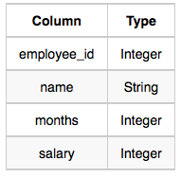

where employee_id is an employee's ID number, name is their name, months is the total number of months they've been working for the company, and salary is their monthly salary.

Solution:

SELECT name

FROM Employee

order by name;